Letter of invitation to tender
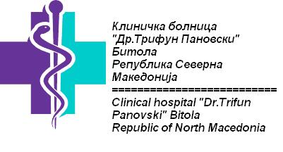
Bitola,24.03.2021

- Our ref.: CN1 – SO1.2 – SC027
Tender 7/2021
Subject: Invitation to tender for Computer network infrastructure within the framework of project “CONTINUITY OF CARE IN METABOLIC DISEASES THROUGH MODERN TECHNOLOGY” implemented under the Greece – Republic of North Macedonia INTERREG IPA Cross-border Programming 2014-2020.
Dear Madam/Sir,

This is an invitation to tender for the above-mentioned supply contract. Please find enclosed the following documents, which constitute the tender dossier:
- Instructions to tenderers
- Draft contract and special conditions, including annexes
- Draft contract
- Special conditions
- Annex I: general conditions
- Annex II + III: technical specifications + technical offer (to be tailored to the specific project)
- Annex IV: budget breakdown (model financial offer)
- Annex V: forms
- Further information
- Administrative compliance grid
- Evaluation grid
- Tender form for a supply contract
Annex 1 - Declaration of honour on exclusion and selection criteria…..Form a.14
For full information about procurement procedures please consult the practical guide and its annexes, which can be downloaded from the following web page: BOLNICABITOLA.MK
We look forward to receiving your tender [and the accompanying tender guarantee] which has to be sent or hand delivered no later than the submission deadline at the address specified in the instructions to tenderers.
By submitting a tender you accept to receive notification of the outcome of the procedure by electronic means. Such notification shall be deemed to have been received by you on the date upon which the contracting authority sends it to the electronic address you referred to in your offer.
If you decide not to submit a tender, we would be grateful if you could inform us in writing, stating the reasons for your decision.
Yours sincerely,
Dr.Biljana Gagachovska,

