Standard advertisement for local publication of local open tender procedures
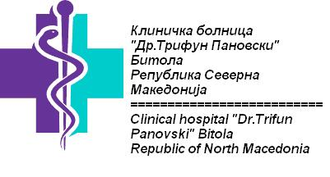

Three(3) laptops
Publication ref :CN1 – SO1.2 – SC027
Tender 2/2019

Clinical hospital Bitola intends to award a supply contract for three(3) laptops in Bitola with financial assistance from the Greece – Republic of North Macedonia INTERREG IPA Cross-border Programming 2014-2020.The tender dossier is available from www.kbb.mk and will also be published on the website of DG International Cooperation and Development:
https://webgate.ec.europa.eu/europeaid/online-services/index.cfm?do=publi.welcome].
The deadline for submission of tenders is <time and date of deadline –must be at least 30 calendar days after the date of publication of this advertisement>.
Possible additional information or clarifications/questions shall be published on thewebsite of DG International Cooperation and Development:
https://webgate.ec.europa.eu/europeaid/online-services/index.cfm?do=publi.welcome

