Standard advertisement for local publication of local open tender procedures
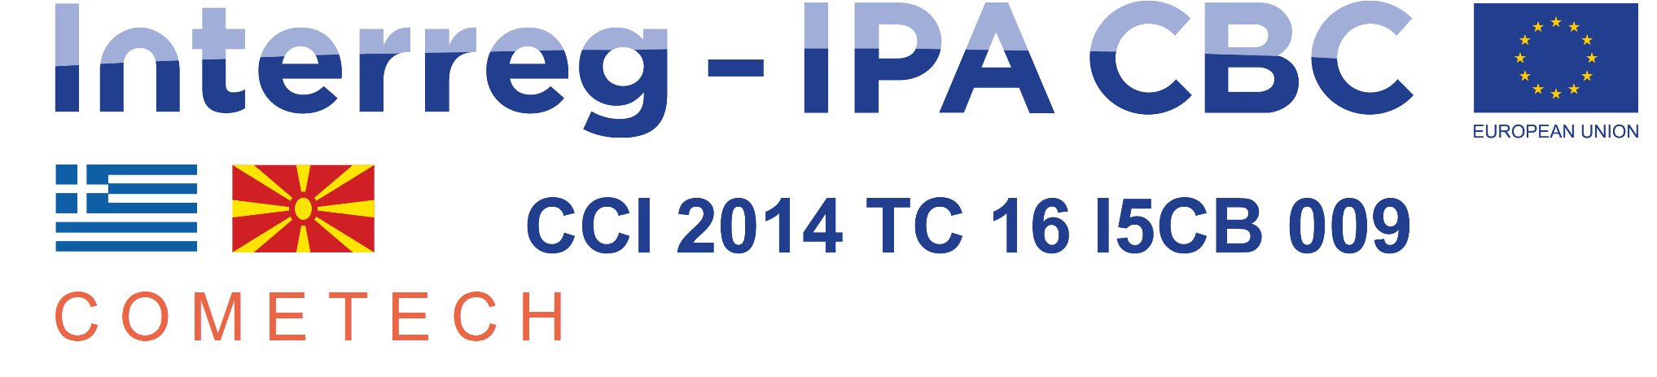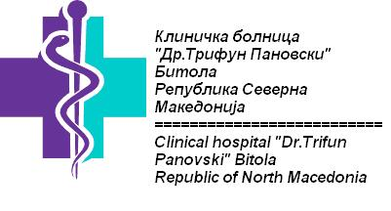

Medical devices - 2
Publication ref :CN1 – SO1.2 – SC027
Tender 3/2019

Clinical hospital Bitola intends to award a supply contract for Medical devices in Bitola with financial assistance from the Greece – Republic of North Macedonia INTERREG IPA Cross-border Programming 2014-2020. The tender dossier is available from www.kbb.mk [and will also be published on the website of DG International Cooperation and Development:
https://webgate.ec.europa.eu/europeaid/online-services/index.cfm?do=publi.welcome].
The deadline for submission of tenders is 16 January 2020.
Possible additional information or clarifications/questions shall be published on the website of DG International Cooperation and Development:
https://webgate.ec.europa.eu/europeaid/online-services/index.cfm?do=publi.welcome

